DVD Rental Business Analysis Report (Sakila Database)

1.Objective
The Sakila Database represents a DVD rental business with two stores, multiple customers, films, and transactions. The goal of this analysis is to derive business insights using SQL queries and a Metric Driven Design (MDD) approach.
The focus areas include:
- Revenue analysis
- Customer behavior
- Film performance
- Store efficiency

2. Business Operations
The following key questions guide the analysis:
- What is the total revenue generated?
- Who are the top customers?
- Which movies and categories are most popular?
- Are there inactive (churned) customers?
- How does revenue change over time?
3.Database Overview
- Customer → Contains customer details like name, email, address, and active status
- Staff → Stores information about employees managing rentals and payments
- Store → Represents the two rental store locations
- Film → Main table with movie details (title, description, release year, rental rate, duration)
- Category → Defines movie genres (Action, Comedy, Drama, etc.)
- Film Category → Links films to categories (many-to-many relationship)
- Actor → Contains actor names
- Film Actor → Links actors to films (many-to-many relationship)
- Language → Stores languages used in films
- Film Text → Holds film titles and descriptions for search purposes
- Inventory → Tracks physical copies of films available in each store
- Rental → Records each rental transaction (who rented, when rented, return date)
- Payment → Stores payment details including amount, customer, staff, and payment date
- Address → Stores addresses of customers and stores
- City → Contains city information linked to countries
- Country → Stores country names

4. Data Model Relationships
The analysis is based on the following key relationships:
- Customer → Rental → Payment → Revenue flow
- Film → Inventory → Rental → Product Usage
- Film → Category → Genre analysis
- Customer → Address → City → Country → Location analysis
5. SQL Analysis & Queries
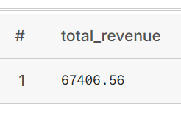
5.1 Total Revenue:
SELECT SUM(amount) AS total_revenue FROM payment;
The total revenue generated by two DVD rental stores is
$67406.56

5.2 Monthly Revenue Trend:
SELECT
DATE_TRUNC('month', payment_date) AS month,
SUM(amount) AS revenue
FROM payment
GROUP BY month
ORDER BY month;
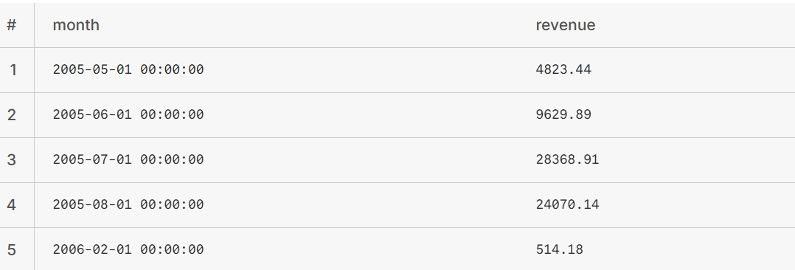

- Based on the monthly revenue trend, it is observed that revenue peaks during July and August, indicating higher business activity in these months.
5.3 Revenue by Store:
SELECT
s.store_id,
SUM(p.amount) AS revenue
FROM payment p
JOIN staff st ON p.staff_id = st.staff_id
JOIN store s ON st.store_id = s.store_id
GROUP BY s.store_id;
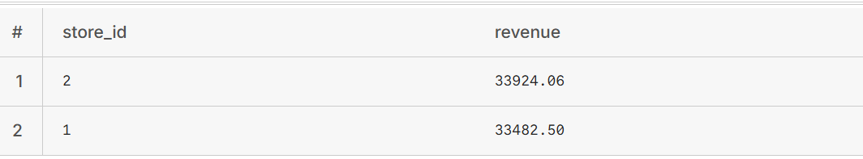
- The revenue comparison across stores indicates that both locations contribute almost equally to the total revenue, reflecting a balanced distribution of business activity.

5.4 Most Rented Movies:
SELECT
f.title,
COUNT(r.rental_id) AS rental_count
FROM rental r
JOIN inventory i ON r.inventory_id = i.inventory_id
JOIN film f ON i.film_id = f.film_id
GROUP BY f.title
ORDER BY rental_count DESC
LIMIT 10;
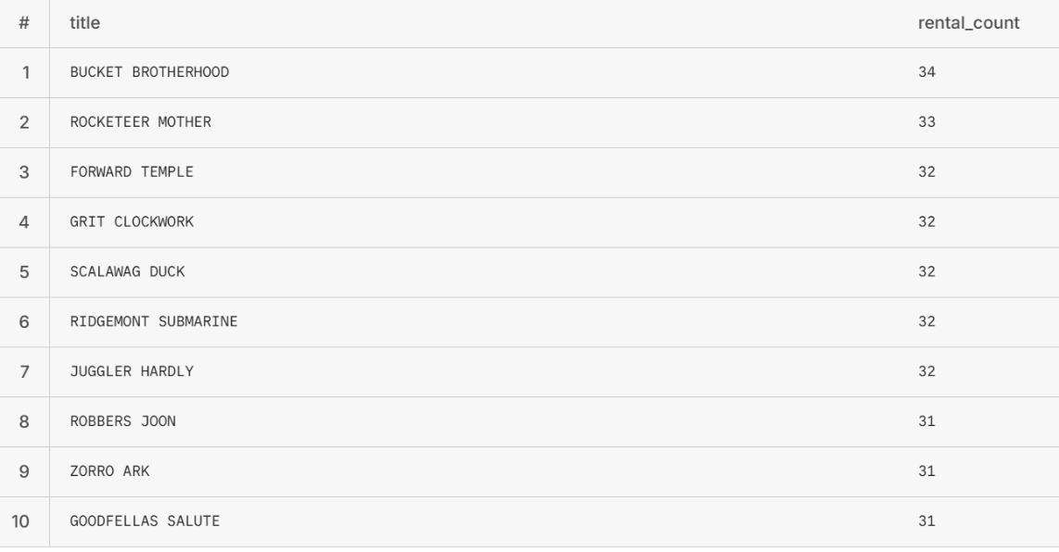
- The results highlight the top 10 most frequently rented movies, indicating the films with the highest customer demand across the stores.

5.5 Most Revenue Generated Movies:
SELECT
f.title,
SUM(p.amount) AS total_revenue
FROM payment p
JOIN rental r ON p.rental_id = r.rental_id
JOIN inventory i ON r.inventory_id = i.inventory_id
JOIN film f ON i.film_id = f.film_id
GROUP BY f.title
ORDER BY total_revenue DESC
LIMIT 10;
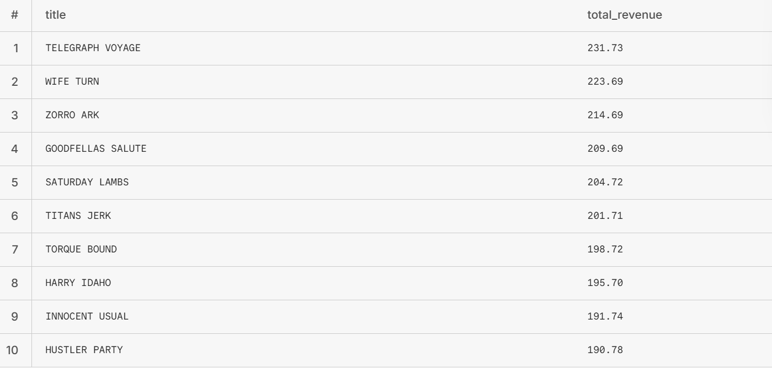
- The results highlight the top 10 revenue-generating movies, indicating the films that contribute the most to overall business revenue.

5.5 Revenue by Film Category:
SELECT
c.name AS category,
SUM(p.amount) AS revenue
FROM payment p
JOIN rental r ON p.rental_id = r.rental_id
JOIN inventory i ON r.inventory_id = i.inventory_id
JOIN film f ON i.film_id = f.film_id
JOIN film_category fc ON f.film_id = fc.film_id
JOIN category c ON fc.category_id = c.category_id
GROUP BY c.name
ORDER BY revenue DESC
LIMIT 5;
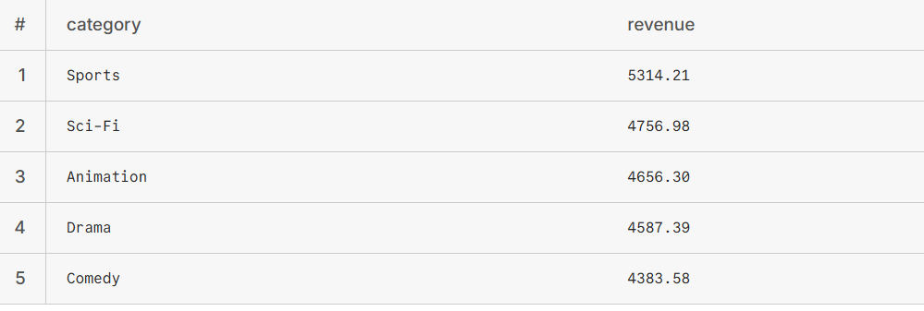
- The results highlight the top 5 revenue-generating movie categories, indicating the genres that contribute most significantly to overall business revenue.
5.5 Revenue by Film Category:
SELECT
c.name AS category,
SUM(p.amount) AS revenue
FROM payment p
JOIN rental r ON p.rental_id = r.rental_id
JOIN inventory i ON r.inventory_id = i.inventory_id
JOIN film f ON i.film_id = f.film_id
JOIN film_category fc ON f.film_id = fc.film_id
JOIN category c ON fc.category_id = c.category_id
GROUP BY c.name
ORDER BY revenue DESC
LIMIT 5;

- The results highlight the top 5 revenue-generating movie categories, indicating the genres that contribute most significantly to overall business revenue.
5.5 Films with No rentals:
SELECT DISTINCT

f.title
FROM film f
JOIN inventory i
ON f.film_id = i.film_id
LEFT JOIN rental r
ON i.inventory_id = r.inventory_id
WHERE r.rental_id IS NULL;
- Movies that have not been rented may be removed from inventory or offered at discounted rates to optimize inventory utilization and enhance revenue generation.
5.6 Customers with High rentals:
SELECT
c.customer_id,
c.first_name,
c.last_name,
SUM(p.amount) AS total_spent
FROM payment p
JOIN customer c ON p.customer_id = c.customer_id
GROUP BY c.customer_id, c.first_name, c.last_name
ORDER BY total_spent DESC
LIMIT 5;

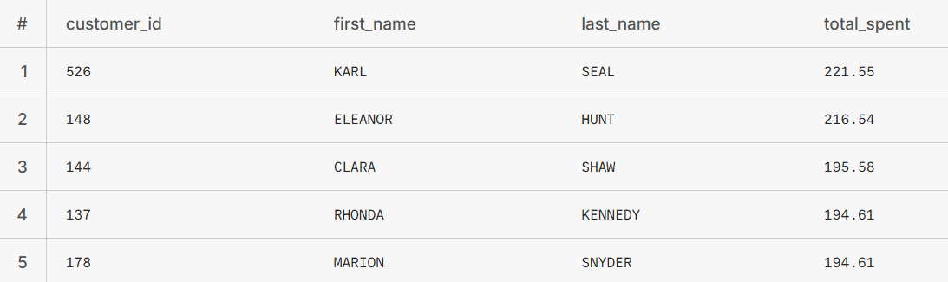

- High-value customers should be rewarded through loyalty programs and incentives to enhance retention and maximize long-term revenue.
6. Business Recommendations:
- Optimize Store Strategies
Since both stores generate nearly equal revenue, efforts should be made to differentiate performance by introducing store-specific promotions or localized marketing strategies.

- Reward High-Value Customers
Customers with high rental frequency should be recognized through loyalty programs, discounts, or exclusive offers to improve retention and long-term revenue.

- Improve Inventory Management
High-performing movies and genres should be stocked in greater quantities, while low-performing titles should be discounted, promoted, or gradually removed from inventory.

- Leverage Seasonal Trends
As revenue peaks in July and August, the business should analyze customer behavior during these months and plan targeted campaigns, offers, and inventory expansion to maximize profits.

- Handle Non-Performing Movies
Movies with zero or very low rentals should be either discounted, bundled in offers, or replaced with more in-demand content to improve inventory efficiency.

- Re-engage Low-Activity Customers
Customers with minimal rental activity should be targeted through personalized promotions, reminders, or special discounts to increase engagement and reduce churn.

Conclusion:
Implementing these recommendations can enhance revenue generation, improve customer retention, and optimize inventory utilization, leading to overall business growth.

